Table of contents
1. Introduction to Project 1
1.1. Purpose this document 1
1.2. Business objective 1
1.3. Indentify the problem 1
1.4. Benefits of Point of Sale system 1
1.5. Scope control 1
1.6. Process of team is Traditional Methodology (Waterfall) 2
1.6.1. Why use Waterfall? 2
1.6.2. Explanation of the Waterfall Model 3
1.7. Time line 4
1.8. Stakeholder role and responsibilities 4
1.8.1. Strong of team members 5
1.8.2. Weak of team members 5
1.9. Project tracking control 6
1.10. Communication plan 6
1.11. Project Budget 6
1.12. Risk plan 7
1.12.1. List the Risk in Project 7
1.12.2. Likelihood 9
1.12.3. Impact 9
1.12.4. Priority 10
1.12.5. Risk Responsibilities 11
1.13. Change management 12
1.13.1. Responsibility 12
1.13.2. Change Management Process 13
1.14. Success criteria 16
2. Architectural driver 16
2.1. High Level Requirements 16
2.1.1. Use-case Diagram 17
2.1.2. Use-case Table 18
2.1.3. Use-case Description 19
2.2. Business constraints 23
2.3. Technical constraints 24
2.4. Quality attributes 24
2.5. Quality Attribute scenarios 24

Introduction to Project

Purpose this document
This project will consist of development and deploy a sales system in conjunction with its laugh of point service – POS (Point of Sale). The project will be completed above in 6 week.
The development team can use this document to review the architecture of the system. The document will be also useful for future development teams

Business objective
- Inventory Management: sale systems use bar code identification in receiving, tracking and selling inventory items. Sale system can also monitor the cost of goods sold, purchase price, sale price and profit margins
- Accounting Automation: a sale system is to simplify the accounting. By increasing information reporting accuracy, retailers gain smoother operations and better information on which to make crucial business decisions

Indentify the problem

Benefits of Point of Sale system

Scope control
How to get there: Point of Sale systems offer a wide selection of features to improve control of your business and save time spent on purchasing, accounting, improve customer service and improve marketing. The features listed in “In Scope” will be development in the sale system above in 6 week and other features are required
In Scope | Uncertain
- Multiple forms of payment: The member the either pays with cash, points, or a combination of the two | - Customer Information: The system automatically records customer names, addresses, credit card information, what they bought
- Price Adjustments: each store can set and use its own actual retail price | - Special Pricing: Sales and specials are easy to control. Begin and end dates can be assigned to products or product groups and the system will automatically handle them.
- Accounting: the system is also capable of performing the statistical analysis on the sales records of all stores in near real-time manner

Process of team is Traditional Methodology (Waterfall)

Why use Waterfall?
The process of team will be applied is Traditional methodology - Waterfall, because:
Overview | 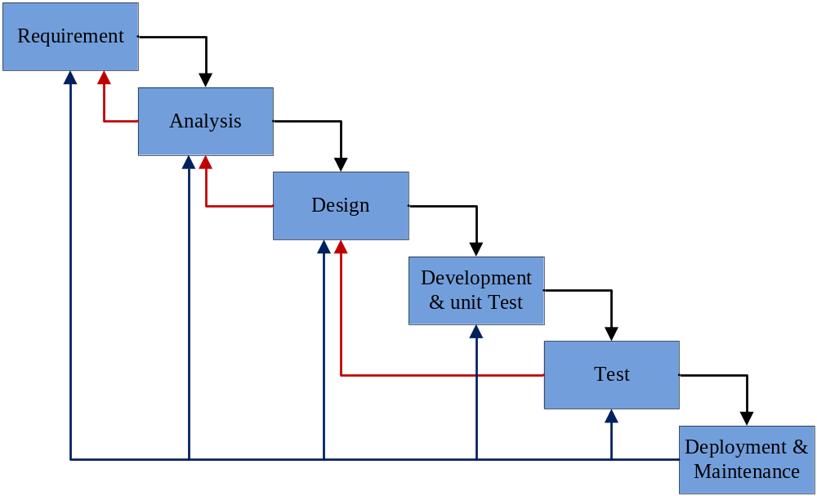  Essentially, it's a framework for software development in which development proceeds sequentially through a series of phases, starting with system requirements analysis and leading up to product release and maintenance. Feedback loops exist between each phase, so that as new information is uncovered or problems are discovered, it is possible to "go back" a phase and make appropriate modification. Progress "flows" from one stage to the next, much like the waterfall that gives the model its name
Explain for Project management | One should use the waterfall model only when:  - Requirements are very clear and fixed.  - There are no ambiguous requirements  - Ample resources with required expertise are available freely  - The client has high confidence in the organization  - The organization has experience of similar projects  - The project is short
Advantages | - The staged development cycle enforces discipline: every phase has a defined start and end point  - Progress can be conclusively identified (through the use of milestones) by both vendor and client  - The emphasis on requirements and design before writing a single line of code ensures minimal wastage of time and effort  - Reduces the risk of schedule slippage, or of customer expectations not being met.  - Getting the requirements and design out of the way first also improves quality  - It's much easier to catch and correct possible flaws at the design stage than at the testing stage  - It is easy to use.  - It guides in making structured, disciplined and stable software product.  - It includes planned and properly defined milestones and baselines

Explanation of the Waterfall Model
Phase | Description
Phase 1: Requirements | The first phase involves understanding what you need to design and what is its function, purpose, …  Here, in this stage, the requirements which the software is going to satisfy are listed and detailed
Phase 2: Analysis | As per the requirements, the software and hardware needed for the proper completion of the project is analyzed in this phase.  Right from deciding which computer language should be used for designing the software, to the database system that can be used for the smooth functioning of the software, such features are decided at this stage.
Phase 3: Design | The algorithm or flowchart of the program or the software code to be written in the next stage, is created now  It is a very important stage. The proper design at this stage, ensures a execution in the next stage. If during the design phase
Phase 4: Development | Based on the algorithm or flowchart designed, the actual coding of the software is carried out.
Phase 5: Test | With the coding of the application complete, the testing of the written code now comes into scene  Testing checks if there are any flaws in the designed software and if the software has been designed as per the listed specifications  A proper execution of this stage ensures that the client interested in the created software, will be satisfied with the finished product  In the design phase, changes are implemented and then the succeeding stages of coding and testing are again carried out.
Phase 6: Deployment and maintenance | A proper execution of all the preceding stages ensures an application as per the provided requirements and most importantly, it ensures a satisfied client  If the client demands further enhancements to be made to the existing software, then the development process must begin anew, right from the first phase, i.e., requirements.

Time line
Milestone / Deliverable | Completion Week
Phase 1: Requirements | End week 1 (on Saturday)
Phase 2: Analysis | End week 2 (on Saturday)
Phase 3: Design | End week 3 (on Saturday)
Phase 4: Development | End week 4 (on Saturday)
Phase 5: Test | End week 5 (on Saturday)
Phase 6: Deployment and maintenance | End week 6 (on Saturday) and in the future

Stakeholder role and responsibilities
Project Role | Who | Project Responsibilities
Sponsor | Nguyen Thuy Huong & Phan Thi Hong | - Provides executive team approval and sponsorship for the project. Has budget ownership for the project and is the major stakeholder and recipient for the project deliverables.
Stakeholder | Company B | - Key provider of requirements and recipient of project deliverable and associated benefits. Deliverable will directly enhance the stakeholders’ business processes and environment.
Project Manager | Le Thi Bich Van | - Make plan and master plan for project.
Project Manager | Le Thi Bich Van | - Assign task, monitor works, Coordinator and relationship in team.
Project Manager | Le Thi Bich Van | - Solve problems in team.
Project Team |  | - Working project team member who analyzes, designs and ultimately improves or replaces the business processes
Recorder (this role will be change over the course of the project) | 1.Le Dinh Thach Huyen  2.Dang Huy Son  3.Do Minh Tam  4.Nguyen Trung Tin | - Draft and give document and material for team members.
 |  | - Support leader draw process model, template.
 |  | - Collect team member’s document.
 |  | - Make product document.
Sub-Leader (this role will be change over the course of the project) |  | - Design and analyze product.
 |  | - Programming.
 |  | - Testing.
Coder (this role will be change over the course of the project) |  | - Programming
 |  | - Testing.
Tester (this role will be change over the course of the project) |  | - Testing.
 |  | - Install program.

Strong of team members
- Each person has a high professional specific ability.
- Have experience in water fall model.
- Have good communicate with each other.
- Have many support from customers.
- Good management tool

Weak of team members
- Lack in many skills.
- Analytical ability and programming is limited.
- Efforts of members is still low.

Project tracking control
- Using effort log report, report status per week
- Measurement and analysis progress using “measurement tools”

Communication plan
What | Who (is involved/receives) | Frequency
Team Meetings | Involved : Team leader  Receives : All team members | Two a week
Meetings with Sponsor | Involved : Team leader  Receives : All team member & sponsor | One a week
Written Status Reports | Involved : Recorder  Receives : Team leader | Every meeting
Other Forms of Communication | Involved : Team leader  Receives : All team members

Project Budget
 | Initial Cost | Recurring Cost

People
- Staffing
- Consultants
- Training/Documentation

System
- Hardware
- Software

Risk plan
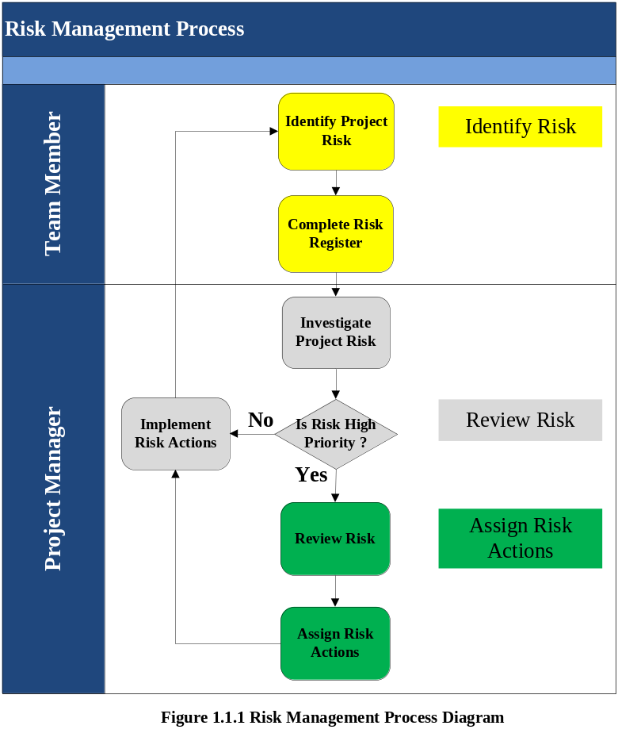

List the Risk in Project
Risk Category | Risk Description | Type Risk ID
Requirement | The requirements have been clearly specified | 1.1
Requirement | The requirements specified do not match the customer’s needs. | 1.2
Requirement | The requirements specified are not measurable | 1.3
Schedule | The Schedule doesn’t provide enough time to complete the project | 2.1
Schedule | The schedule doesn’t list all the activities and task required | 2.2
Schedule | The schedule doesn’t provide accurate dependencies | 2.3
Schedule | The overall delivery timeframe is insufficient to produce all of the deliverable | 2.4
Deliverables | The deliverables required by the project are not clearly defined | 3.1
Deliverables | Clear quality criteria for each deliverables have not been defined | 3.2
Deliverables | The deliverables produced doesn’t meet the quality criteria defined  . So requiring redesign and rework | 3.3
Scope | The scope of the project is not clearly outlined | 4.1
Scope | The project is not undertaken within the agreed-upon scope | 4.2
Scope | Project changes negatively impact on the project | 4.3
Issue | Project issues are not resolved within an appropriate timescale | 5.1
Issue | Similar issues continually reappear throughout the project | 5.2
Issue | Unresolved issues become new risks to the project | 5.3
Acceptance | The criteria for accepting project deliverables aren’t clearly defined | 6.1
Acceptance | Customers do not accept the final deliverables of the project | 6.2
Acceptance | The acceptance process leaves the customer | 6.3
Communication | Lack of controlled communication causes project issues | 7.1
Communication | Key project stakeholders are “left in the dark” about progress | 7.2
Resource | Member allocated to the project are not suitably skilled | 8.1
Resource | Insufficient equipment is available to undertake the project | 8.2
Resource | There is a shortage of member available when required (because missing member, …) | 8.3

Likelihood
Title | Score | Description
Very Low | 20 | The risk is highly unlikely and will be recorded but not monitored
Low | 40 | The risk is unlikely but will be monitored throughout the project
Medium | 60 | The risk likely as it is clear that the risk may occur
High | 80 | The risk very likely, based on the circumstances of the project
Very high | 100 | The risk is high likely, as the circumstances that will cause this risk to occur are also very likely to occur

Impact
Title | Score | Description
Very Low | 20 | The risk will have an insignificant impact on the project
Low | 40 | The risk will have a minor impact on the project (< 5% deviation in scope, schedule end – date)
Medium | 60 | The risk will have a measurable impact on the project (5% - 10% deviation in scope, schedule end – date)
High | 80 | The risk will have a significant impact on the project (10% - 25% deviation in scope, schedule end – date)
Very high | 100 | The risk will have a major impact on the project (25% + deviation in scope, schedule end – date)

Priority
The priority score is calculated as the average of the Likelihood and Impact (Ex. [Likelihood + Impact] / 2)
Color – Code key
Priority
Score | Rating | Color
0 – 20 | Very low | White
21 – 40 | Low | Green
41 – 60 | Medium | Yellow
61 – 80 | High | Orange
81 – 100 | Very High | Red

Risk ID | Likelihood Score | Impact Score | Priority Score | Priority Rating
1.1 | 40 | 80 | 60
1.2 | 20 | 40 | 30
1.3 | 90 | 40 | 70
2.1 | 80 | 80 | 80
2.2 | 20 | 80 | 50
2.3 | 80 | 60 | 70
2.4 | 80 | 50 | 65
3.1 | 50 | 80 | 65
3.2 | 50 | 80 | 65
3.3 | 40 | 80 | 60
4.1 | 20 | 80 | 50
4.2 | 10 | 80 | 45
4.3 | 20 | 80 | 50
5.1 | 50 | 60 | 55
5.2 | 20 | 60 | 40
5.3 | 50 | 70 | 60
6.1 | 20 | 80 | 50
6.2 | 10 | 100 | 55
6.3 | 10 | 100 | 55
7.1 | 50 | 80 | 65
7.2 | 50 | 80 | 65
8.1 | 80 | 80 | 80
8.2 | 50 | 60 | 55
8.3 | 80 | 80 | 80

Risk Responsibilities
Role | Responsibilities
Team member | The Project Team is responsible for:
Team member | - Identifying risks within the project
Team member | - Completing a Risk Register for each risk identified
Team member | - Completing all risk actions assigned by the Project Manager
Project manager | The Project Manager is responsible for:
Project manager | Reviewing all risks to determine their priority
Project manager | Implementing risk actions for low/ medium priority risks
Project manager | Reviewing risk after risk actions have been undertaken
Project manager | Reviewing high priority risks before
Project manager | Identifying actions required to avoid, transfer or mitigate high priority risks

Change management
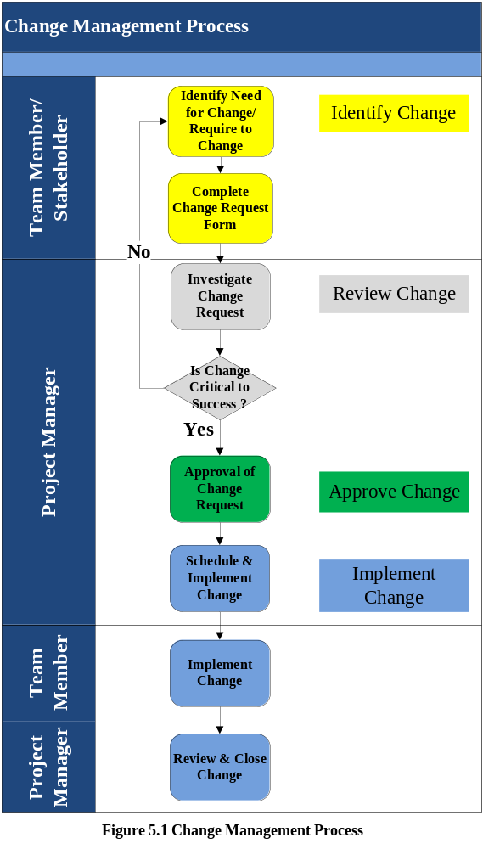

1.13.1. Responsibility
The person responsible for Change Management | Responsible
Project Change Manager (with Project Team) | Develop Change Management Plan.
Project Change Manager & Project Manager | Mitigating or performing change management process. This process may result in changes to the scope, schedule, cost, and quality of plans. You may need to add resources
Members of Project Team appointed | Keep a log of change requests
Project Manager | Steering review of all change management activities with the senior management periodically  Ensure resources and appropriate funding available to assist the implementation of Change Management Plan  Ensure Change Management Plan is executed

1.13.2. Change Management Process
Change Management Process is made up the following steps in SMS project:
Change Management Process occur in seven steps:
- Identify Need for Change
- Complete Change Request Form
- Investigate Change Request
- Schedule and Implement Change
- Review and Close Change
1.1.Identify Change
The first step in the change process is to identify the need for change. Any team member can suggest a change to project, if he/ she believes it is needed to keep the project producing deliverables to customer’s specified requirements or other stakeholder require to change. After indentifying a need for change, the team member records relevant information on a Change Request Form (commonly called a CRF), describing the change, and identifying driver, benefits, costs and likely impact of the change on the project. The CRF is forwarded to the Project Manager for review and approval.
1.1.1. Identify Need for Change
This “Need for Change” must be formally recognized in order to ensure that the change can be controlled through the change process. To ensure that the project is diverted from producing its deliverables on time, the following guidelines will be used to validate each change for approval:
- Only change request made by project made by project directors, management or staff will be considered
- Change must be critical to the project achieving its objectives
- The benefit of each change must measurably outweigh the costs
- The change should not have any high priority issues or risks associated with it
1.1.2. Complete Change Request Form
One a team member has formally identified the change and determined through the above guidelines to be valid, they will document the change using a Change Request Form (CRF). This form allows the team member thoroughly described of the change requested, as well as its drivers, benefits, costs and impact on the project
One complete, the CRF is forwarded to the Project Manager for approval
1.2.Review Change
The Project Manager investigates the change to identify the reason for it and its impact. Then he/ she decides whether it is critical to the successful delivery of the project. Change which are not critical to project delivery should be avoided whenever possible to prevent “scope creep”
If the change is deemed critical to success, the Project Manager either approves the request or seeks approval for the CRF raised.
1.2.1.Investigate Change Request
1.3.Approve Change
After review change the Project Manager review details in the CRF to determine whether or not the change should be implemented. Based on the level risk, impact, benefits, and cost to the project, it may decide to decline, delay or approve the change request
1.3.1.Implement Change
The Project Manager approve all changes, which are then are schedule and implemented accordingly. After implementation, the Project Manager review the effects of the change on the project ensure that it achieved the desired outcome, when change is then close in Change Register
Throughout the Change Management Process, the Project Manager can monitor and control changes to the project by keeping this Change Register up – to – date
1.3.2.Schedule and Implement Change
Following the approval of the Change Request (by either the Project Manager), the actions required to implement and communicate the change are scheduled. These actions should be schedule for date and time which have minimal impact on the project
1.3.3.Review and Close Change
After implementation of the approved change, the Project Manager will review the project to determine whether the change action have had the desired effect
The detailed description of the change management process:
- The CR is reviewed daily by the Project Manager or Change Manager, and assigned one of four results:
- Eliminate | - The notice is sent to the proponent  - The submission may request a review (to the project team)  - The project team reviewed CR in later meetings
- Deferred: | - Project Team is scheduled to review the CR on the a predetermined date  - Inform the proposed  - The submission can not agree and request again  - Project Team review at their CR meeting
- Accept analysis immediately | - Assign a person begins analyzing the impact  - Project Team be notified
- All of the CR is pending to review at project team meetings. The results can be:
- Eliminate: | - Report submitted to the  - Persons may submit objections (to the Project Manager, and possibly to the the monitoring committee)  - A review of the Project Manager is final
- Deferred: | - Project Team is scheduled to review the CR on the some day  - Inform the proposed
- Accept analyzing | - Assign a person begins analyzing the impact  - Inform the proposed
- When analyzing is complete, the project team review the analysis results. The results can be:
- Eliminate: | - Notify the proponent  - People can submit proposals to the Project Manager  - Consideration of the Executive Committee is final
- Accept | - Project Team accept the nomination of the analyzing  - Notify Project Manager as follows:  - CR affects less - Just notice, do not require any action  - CR Impact medium - Project Manager is required review, and no other activities required  - CR influenced - Project Manager approval is required
- Return to analyze more | Project Team has questions or request to be sent back to the analyzing for further consideration
- CR is accepted to be forwarded to the Project Sponsor to review the nominations. The results can be:
- Eliminate | - Notify the proposed  - Persons may submit proposals to the Project Manager  - Consideration of the Project Manager is final
- Accept | - Notify the proposed  - Project Team update the project documents related  - Project Team plans again  - Project Team works on new plan
- Return to analyze more | - Project Manager have questions or suggestions are sent back to the analyzing for further consideration  - Notify the proposed  - The analysis's recommendation is reviewed by the project team (back to step 1)

Success criteria
The project will be determined successful if the sells system to meet the functional requirements, constraints (business & technical) and quality attributes

Architectural driver

High Level Requirements
ID | Functional Requirement | Description | Status
FR.01 | Sale management | Support user to make a sale operation, export and print invoices to customer. | Doing
FR.02 | Customer management | Support user to add, edit or disable customer information. | Doing
FR.03 | Point reward management | Support user to fix the point award rate, and stored in the system.  The awarded points become valid for use the following day. | Off
FR.04 | Product management | Support user to manage product, product category, product amount. | Doing
FR.05 | Synchronization & Price management | Support user to manage product price include standard price and retail price. | Doing
FR.06 | System management | Support to synchronize data between clients and server.  Before business hour starts, the system executes a batch process which post-processes the sales operations form previous day, and prepares for the daily sales operations. | Off
FR.07 | Statistic and report | Support user to make statistics and reports on the sales records of all stores in near real-time manner | Off
FR.08 | User management | Manage cashier information in system | Off

Use-case Diagram
Actor | Description
Admin | Admin has responsible in manage shop, goods in shop and price of them.
Cashier | Cashiers will have responsible to calculate goods price, customer’s score
Timer | System component. Auto record transactions in payment progress and auto sync between client and server.

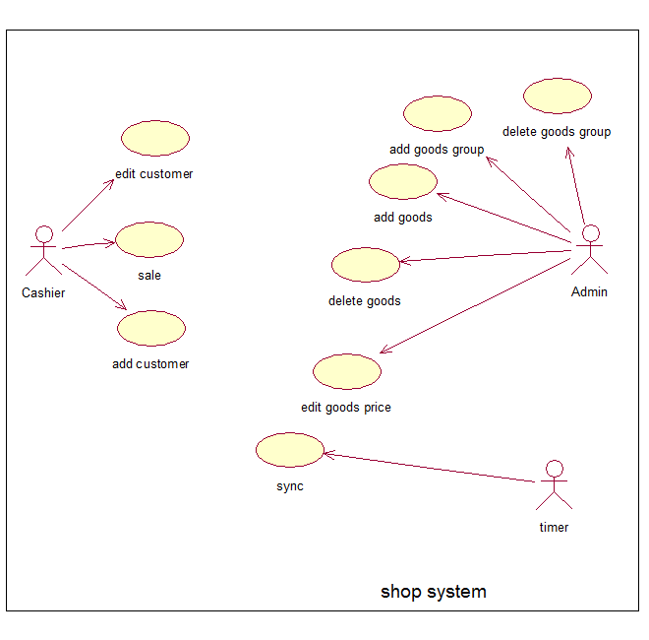

Use-case Table
Use-case ID | Name
UC01 | Add customer
UC02 | Edit customer
UC03 | Sale
UC04 | Add goods
UC05 | Edit goods price
UC06 | Delete goods
UC07 | Add goods group
UC08 | Delete goods group
UC09 | Sync

Use-case Description
Use-Case ID:UC01 | Use-Case Name: add customer
Actor: cashier
Description: | Support actor to add customer information in system.
Preconditions: | Customer ID is not exist in system.
Primary Pathway: | - Actor click “create new customer” button.  - Actor fill customer information in form.  - Click “ok”.  - Program will check information.  - Sent new customer to server.  - Shop server check new customer information.  - Store into shop server database and send to main server.  - Main server sync new information between the others shop server.
Alternative Pathways: | - Check in database and see this customer ID is already exist, return to main screen and show message “ID is already exist, can not create new customer”.
Exception Pathways:
Includes
Extends | None

Use-Case ID:UC02 | Use-Case Name: Edit customer
Actor: cashier
Description: | Support actor to edit customer information in system.
Preconditions: | Customer ID already exist in system.
Primary Pathway: | - Choose customer that actor want to edit.  - Click “edit” button.  - Edit information show on form.  - Click save.  - Program check input information.  - Program send new information to shop server.  - Shop server will check and send to main server.  - Main server will sync new information between the others shop server.
Alternative Pathways: | - Program check information, if invalid, do not send new information to shop server and show message “ invalid input”.
Exception Pathways:
Includes
Extends | None

Use-Case ID:UC03 | Use-Case Name: Sale
Actor: cashier
Description: | Help actor calculate money customer must pay and calculate customer score.
Preconditions:
Primary Pathway: | - Type the bar code or use barcode reader to input barcode into computer.  - After scan all goods, click “finish”.  - System will calculate money and show total that customer must pay on screen.
Alternative Pathways: | - If customer has member card, system calculate customer score and add to customer account.
Exception Pathways:
Includes
Extends | None

Use-Case ID:UC04 | Use-Case Name: add goods
Actor: admin
Description: | Support actor to add new goods information in system.
Preconditions: | Goods is not exist in system.
Primary Pathway: | - Actor click “create new goods” button.  - Actor select what ever he want in list to his shop.  - Click “ok.  - Shop server check new goods in system.  - Store into shop server database.
Alternative Pathways: | - Check in database and see if new goods is already exist, return to main screen and show message “already exist, can not create new goods”.
Exception Pathways:
Includes
Extends | None

Use-Case ID:UC05 | Use-Case Name: edit goods price
Actor: admin
Description: | Support actor to edit goods price in system.
Preconditions: | Goods is exist in shop system.
Primary Pathway: | - Actor choose a goods.  - Click “edit price” button.  - Change price of goods.  - Select time to apply change.  - Click “Ok” button.  - New price is store in shop database  - Program show message “edit successful”
Alternative Pathways:
Exception Pathways:
Includes
Extends | None

Use-Case ID:UC06 | Use-Case Name: delete goods
Actor: admin
Description: | Help actor delete goods in shop system.
Preconditions: | Goods is exist in shop system.
Primary Pathway: | - Actor choose a goods.  - Click “delete” button.  - Program remove that goods in system.  - Program show message “delete successful
Alternative Pathways:
Exception Pathways:
Includes
Extends | None

Use-Case ID:UC07 | Use-Case Name: Add goods group
Actor: admin
Description: | Support actor to add new goods group information in system.
Preconditions: | Goods group is not exist in system.
Primary Pathway: | - Actor click “create new goods group” button.  - Actor select what ever he want in list to his shop.  - Click “ok.  - Shop server check new goods group in system.  - Store into shop server database.
Alternative Pathways: | - Check in database and see if new goods group is already exist, return to main screen and show message “already exist, can not create new goods group”.
Exception Pathways:
Includes
Extends | None

Use-Case ID:UC08 | Use-Case Name: Delete goods group
Actor: admin
Description: | Help actor delete goods group in shop system.
Preconditions: | Goods group is exist in shop system.
Primary Pathway: | - Actor choose a goods group.  - Click “delete” button.  - Program remove that goods group in system.  - Program show message “delete successful
Alternative Pathways:
Exception Pathways:
Includes
Extends | None

Use-Case ID:UC09 | Use-Case Name: Sync
Actor: timer
Description: | Help system auto sync transaction information between client, shop server and main server.
Preconditions:
Primary Pathway: | - After each 1 hour, system auto send all data of shop server in list to main server.
Alternative Pathways: | - After a day, main server will send new information about customer score, customer information, new goods or goods group of system to all shop servers.
Exception Pathways:
Includes
Extends | None

Business constraints
ID | Constraints
BC.01 | Design, develop and deploy the system in 6 weeks
BC.02 | Have 6 week for working
BC.03 | The bonus point rate is fixed, and stored in the system as constraint
BC.04 | Point are recorded in the system, and not on card The awarded points can be used by the member who accrued the points in place of cash when making a purchase. Points can be used in all stores.
BC.05 | The bonus points become valid for use the following day
BC.06 | The number of points used is immediately subtracted from the number of points accrued by the
BC.07 | For each product, its standard price, common to all stores
BC.08 | The system executes a batch process which post-processes the sales operations from previous day, and prepares for the daily sales operations
BC.09 | Develop team just have 5 members. Lack of skills

Technical constraints
ID | Constraints
TC.01 | The head office server and the POS terminals are connected each other via a network.
TC.02 | SQL Server Database, server and client use local database for system
TC.03 | Both the head office server and the POS terminals are equipped with a Database
TC.04 | Both the head office server Database and the POS terminal Database can be accessed during the sales operation
TC.05 | The product codes can read with bar code readers of POS terminals
TC.06 | Since no bar code reader, user can enter these codes by using computer keyboard

Quality attributes
ID | Quality Attribute
QA.01 | Performance
QA.02 | Availability
QA.03 | Usability
QA.04 | Security

Quality Attribute scenarios
Availability Scenario. The system provides failover when incidents occur
Portion of scenario | Possible value
Source | Internal
Stimulate | System failure
Artifact | System, server – POS clients
Environment | System operating environment (runtime)
Response | Use local database any when to protect system against cracking.
Response measure | No down time.

Performance Scenario. The system execute transaction immediately
Portion of scenario | Possible value
Source | Cashiers – administrators
Stimulate | Initiate transactions
Artifact | POS clients
Environment | System operating environment (runtime) – normal mode
Response | When the points are used, the number of points used is immediately subtracted from the number of points accrued by the member.  Member point will be stored in local database.
Response measure | Average latency immediately (within 5s)

